**Name :** R.Muralidhar Reddy

**Trainer Name :** Harshee Pitroda

**Course :** Basics of Python and ML

**Date :** 03-06-2022

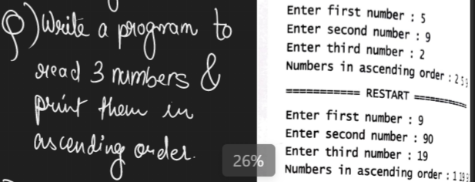

**Q1**

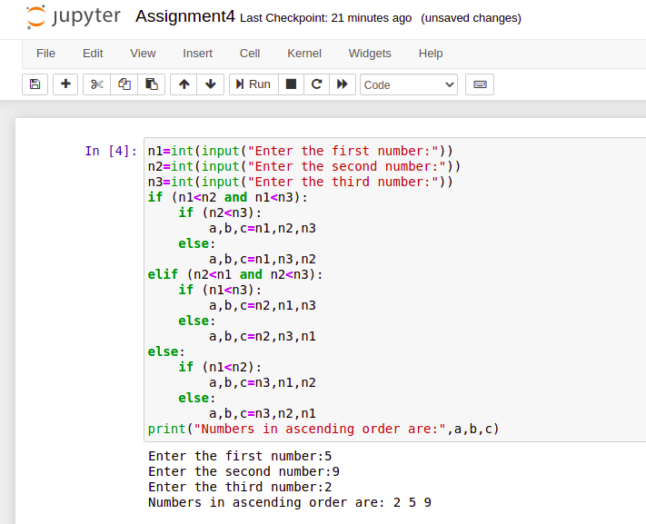

**Q2**

